Chapter 9, Problem 61.

Find Z_{eq} in the circuit of Fig. 9.68.

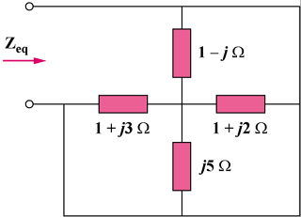

Figure 9.68
For Prob. 9.61.

